Question 1:

Object:
Create a PAC (Program Analysis Chart) for a program that calculates the total cost of a meal including tax (as a percentage) and tip. Display the final cost after tax and tip.

PROGRAM ANALYSIS CHART

Given Data | Expected Outcome
Meal cost  Tax percentage  Tip percentage | Final total cost
Process Required | Situation Alternatives
tax amount = (meal cost × tax%) ÷ 100.  tip amount = (meal cost × tip%) ÷ 100.  final cost = meal cost + tax amount + tip amount. | If tax = 0 → Final = meal + tip  If tip = 0 → Final = meal + tax  If both tax & tip = 0 → Final = meal only  If meal cost ≤ 0 → Invalid input

Question 2:

Object:
Draw an IPO (Input-Process-Output) chart for a program that calculates the area of a circle.
Formula: Area = π * radius²

INPUT PROCESSING OUTPUT CHART

Input | Process | Module Reference | Output
Radius of circle | Area = π × radius² | READ Radius  CALCULATE Area= π × radius²  PRINT Area | Area of the circle

Question 3:

Object:
Write a step-by-step algorithm to calculate the body mass index (BMI) of a person.
Formula: BMI = weight (kg) / (height (m))².

ALGORITHM

Step 01: Start the Program.
Step 02: Declare variables Name, Weight, Height, BMI.
Step 03: Read Name, Weight (in kilograms), Height (in meters).
Step 04: Calculate BMI = Weight / (Height × Height).
Step 05: Write: "Hi {Name}, your BMI is {BMI}."
Step 06: Stop the Program.

Question 4:

Object:
Write pseudocode for a program that calculates the distance traveled by a car and display it.
Calculate the distance using the Formula: Distance = Speed * Time.

PSEUDO CODE

STARAT
INPUT Speed
INPUT Time
SET Distance = Speed * Time
OUTPUT “The Distance is: ” + Distance
STOP

Question 5:

Object:
Draw a flowchart that represents the process of converting a distance from miles to kilometers.
The flowchart should start with receiving the distance in miles as input. It should then process the calculation (kilometers = miles * 1.60934) and finish with displaying the output (the distance in kilometers). Use standard flowchart symbols.

FLOWCHART

Write Kilometers
Kilometers = Miles * 1.60934
Start
Declare variables Miles, Kilometer
Read Miles
Stop

Question:6

Object:
Create a Scratch program where a sprite introduces itself and changes its appearance.
1. When the green flag is clicked, the sprite says “Hello! I am a Scratch sprite!” for 2 seconds.
2. The sprite then asks “What is your name?” and waits for the user to type an answer.
3. After getting the answer, the sprite says “Nice to meet you, [answer]!” for 2 seconds.
4. Finally, the sprite changes its costume to a different pre-existing costume and changes its color effect.

SCRACH
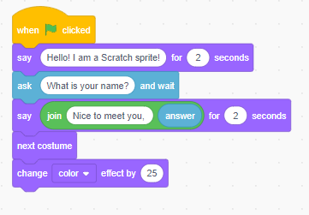

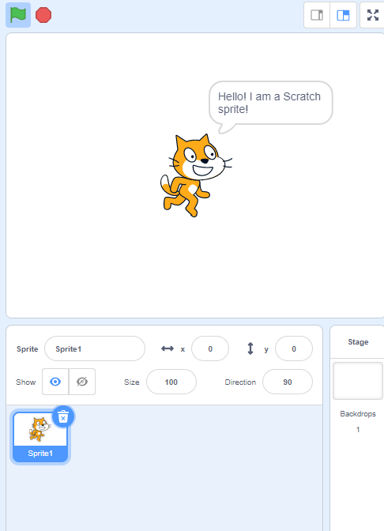

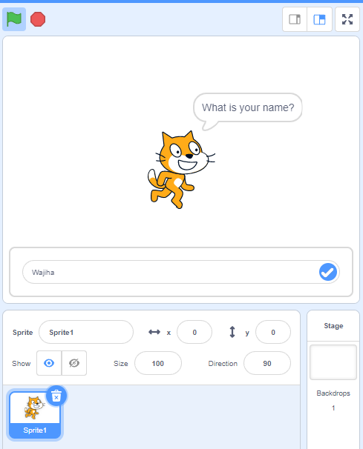

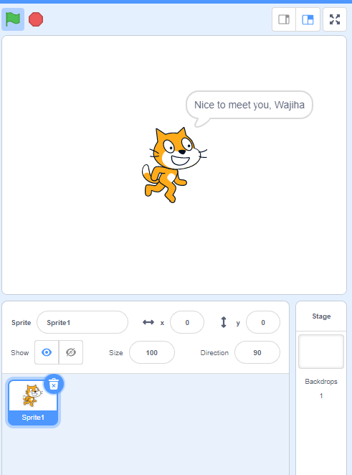

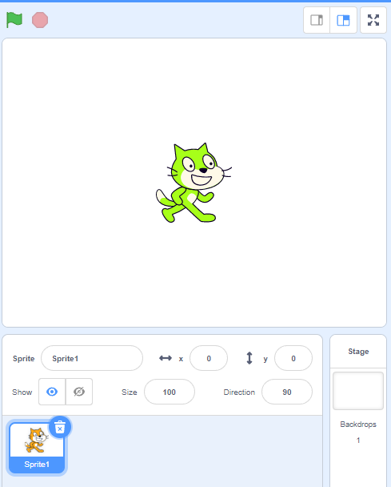

Question:7

Object:
Create a Scratch program where a sprite moves around the stage in a simple pattern. When the green flag is clicked, the sprite goes to the center of the stage (x:0, y:0).
The sprite then glides to four different positions on the stage one after another:
- First, glide to the top (x:0, y:100)
- Second, glide to the right (x:100, y:0)
- Third, glide to the bottom (x:0, y:-100)
- Fourth, glide to the left (x:-100, y:0)
Each time the sprite reaches a new position, it should say “Hello!” for 1 second. After visiting all four positions, the sprite returns to the center and says “That was fun!”.

SCRACH
